Homework 8 - Exchange Rates

Jamie Gashler - Java Programming I

* The reason we use a buffer for IO is because we want to reduce the number of trips the data has to take to the JRI. Essentially this means it helps reduce the number of read and write calls to make the code more efficient and run faster.
* The JNI is the Java Native Interface. This interface allows Java to interact with code written in another language.
* Checked Exceptions are checked at compile time and should be handled with a try-catch block. Unchecked Exceptions are checked at runtime and are often due to invalid data provided by the user. Error Exceptions are JVM level exceptions and you can’t do anything to stop them except change your code within the application.
* The methods that are required to be overridden when using Objects in Sets are the equals() and hashCode() methods. In order to compare objects you need the equals method, and there is a general contract for Object.hashCode() where you must override hashCode() in every class that overrides equals(). Without overriding both, you risk preventing your class from functioning properly.

**Test Case 1:**

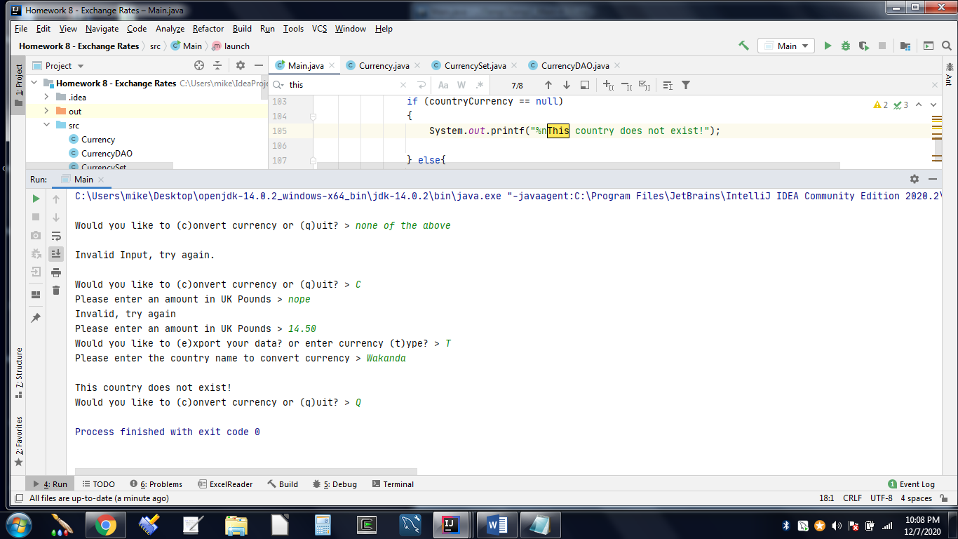

**Test Case 2:**

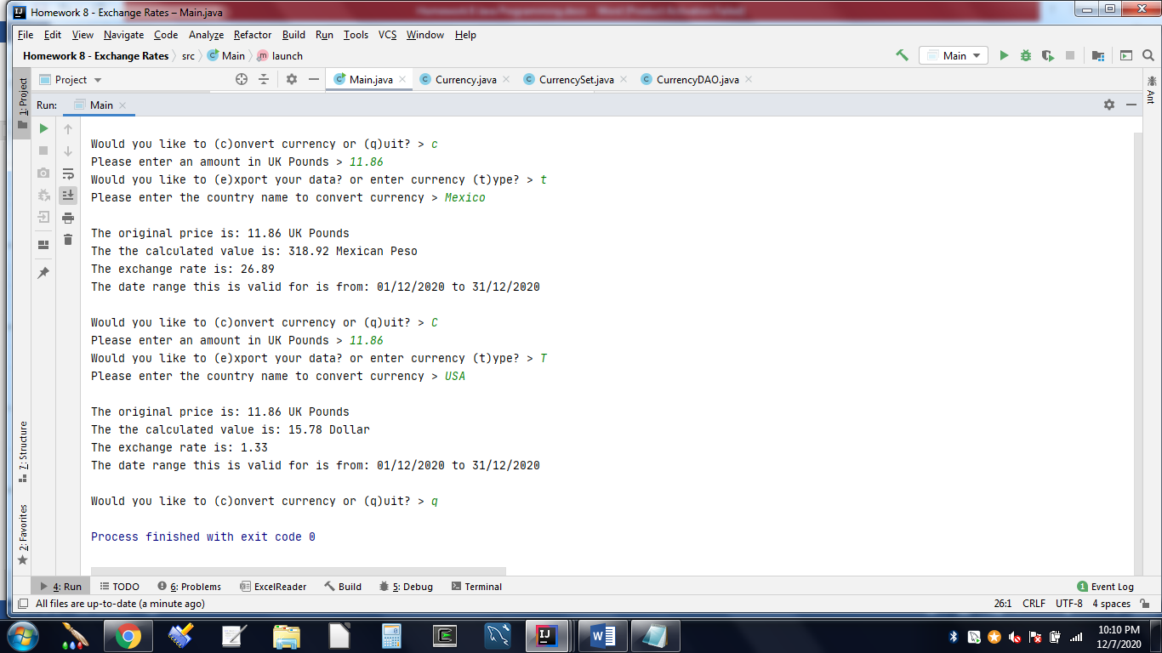

**Test Case 3:**

